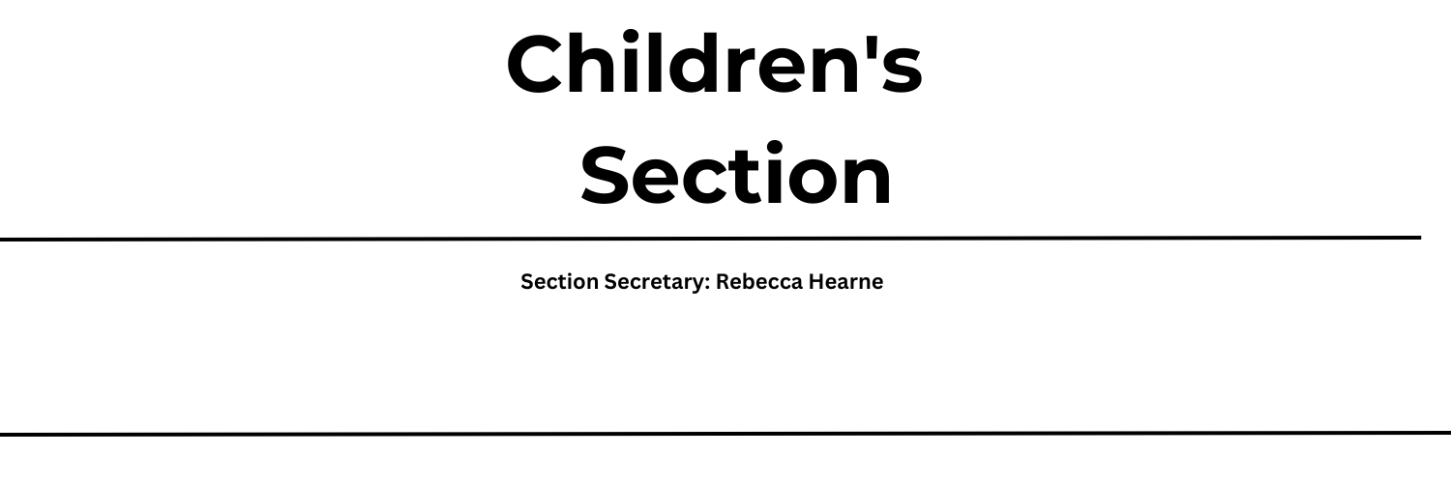

The theme has been selected to reflect on the wonder of flight and how humans have studied nature to find our own ways to fly.
This covers such a huge area, from insects and birds who have the natural ability to fly, through to humans who have studied nature and over the years have developed their own techniques to take to the air – some more successful than others!
We welcome entries covering flight from any and all perspectives. Children are invited to enter any of the classes outlined below and are encouraged to research flight in nature OR the history of flight to give them inspiration.
How To Enter
First you need to decide which class you would like to make something for - you can enter as many different classes as you like and have more than one entry per class, so for example - if photography is your thing, you can enter as many photo’s as you like. If you’re more of an artist, give us a few of your favourite flight related ideas.

Next, make your amazing entry. We are excited to see how the Flight topic is interpreted. Whether you make something complicated, simple, colourful or plain, all entries are unique and we can’t wait to see what you come up with!

Finally, bring your masterpiece on showday -Saturday 3 rd August from 9am – 12:00.
Find the Childrens tent where we will meet you to register your entry and display it ready for the judges. T
he tent will be closed for half an hour for judging between 12:30 and 13:00, after which, you will be able to come back and see the results.
WISHING YOU THE VERY BEST OF LUCK!!
All Classes are Free to Enter
Polite reminder – children under 16 enter both the Emley Show and their artwork free of charge - but
must be accompanied by a full paying adult

Prizes
1st– Paper Planes to Fold & Fly Book
2nd– Rosette
3rd – Rosette

 | Age 3-4 | Age 5-8 | Age 9-11 | Age 12-15
Recycled art | 950 | 951 | 952 | 953
Photography  Sponsored By Sarah Garg Civil Celebrant | X | 954 | 955 | 956
Lego model | X | 957 | 958 | 959
Baking – healthy sweet treats | 960 (decorating a sweet treat) | 961 | 962 | 963
Handwriting / Poetry | X | 964 | 965 | 966
Painting, Pencil, Crayons | 967 | 968 | 969 | 970
Handicraft  Sponsored by Cockley Woods Cabbage Creek | 971 | 972 | 973 | 974
‘Recycled art’ is a freestyle class – children may enter a model, collage, painting, sculpture, or handicraft. The only requirement is that the materials used should be predominantly recycled from household waste, such as old clothes, packaging, natural materials found in the wild etc.

