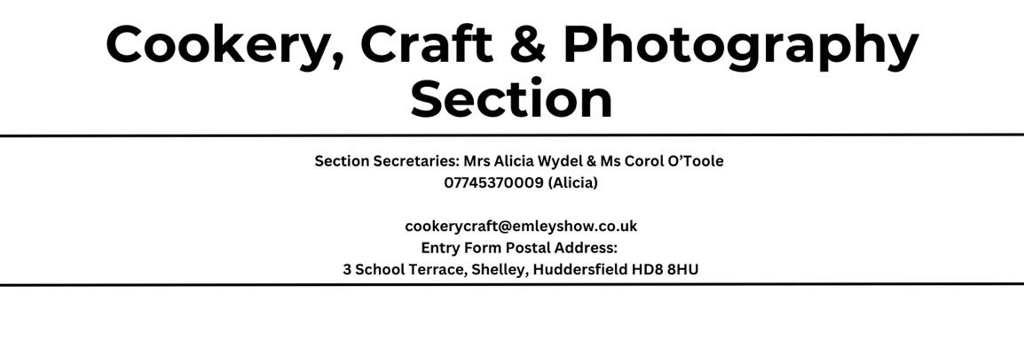

RULES OF THIS SECTION

The full rules and guidance for this section are now available via our website

www.emleyshow.co.uk via the dropdown tab “Section Classes” then selecting

“Cookery, Craft and Photography”. There is an online entry form unique to our

section on our website page. All you have to do is complete it, print it and post it

to the entry form postal address given above.

If you need any further clarification pleases contact Alicia Wydell (as above)

All prize money for all three sections has very kindly been donated by

Manor Services – many thanks for your sponsorship

HANDICRAFT CLASSES

Prizes: 1st - £5 Each 1st, 2nd & 3rd awarded entry in each class will receive a rosette

Special prize awarded to exhibitor with most points in classes 901-908

£10 – kindly donated by Clayton West W.I 2023 winner was Wendy Lunn

Handicraft Class 906 kindly sponsored by Eco Hub Emley Business Park

Judge: Anne Starkey

901 – Make Do and Mend : Repurpose a garment into another project incorporating decorative stitching (please include photograph of original item)

902 - Traditional Hand Embroidery :List of examples noted below

903 – Knitted or Crochet Blankets

904 – Creative Textiles (mixed media) Lanscapes

905 – Soft Toy e.g. Fabric/ Knitted/ Crochet

906 – Any Other Handicraft (hard materials) e.g. Stained Glass, Wood, Clay, Stone, Metal

907 – Handmade Cushion (any size or materials)

908 – Handmade Christmas Card

LIST OF CATEGORY 902 EXAMPLES
Surface Embroidery – Line Stitches, couching, chain stitches, band stitches, cretan and feather stitch, satin stitches, long and short stitch, raised stitches, crewel work, insertion stitches and laidwork
Needlepoint – Diagonal stitches, eyelets, square stitches, leaves and flowers, textured stitches, and bargello embroidery
Counted Thread Embroidery – Assisi work, counted cross stitch, blackwork, drawn thread work hardanger and pulled work
Metal Thread Embroidery – Goldwork and Or Nue
Other Techniques – Beadwork, cutwork, broderie anglaise, ribbon work, shadow work, smocking and stumpwork

PHOTOGRAPHY CLASSES
No more than 10 entries per class
Prizes: 1st - £5
Rosettes: Each first, second and third awarded entry in each class.

912 – Trees

913 - Funny Pets/ Animals

914 – The Colour Blue

COOKERY CLASSES

Jars to have screw tops and can be of any size.

Prizes: 1st - £5

Rosettes: Each first, second and third awarded entry in each class will receive a rosette

The Sylvia Edmondson Trophy awarded to exhibitor with most points in classes

915-929. 2023 winner was Paul Thewlis

Special prize kindly donated by ORIGIN (of Fenay Bridge) to be awarded by judges to “best

in show” in cookery section. 2023 winner was Joanne Davis

Judges: Damian Hunsley, Shelley Connell, Ben Davis & Jayne Percival

915 – Victoria Sandwich

916 – Jar of Curd : Any Flavour (please label stating flavour)

917 – 3 Flapjack : Any Flavour

918 – Decorated Cake : Any Theme

919 – Quiche Lorraine (Traditional Recipe : Eggs, Cheese, Bacon & Onions)

920 – Jar of Chutney : Any Flavour (please label stating flavour)

921 – 3 Millionaires Shortbread

922 – Egg Custard : Pastry Based

923 – 2 Chocolate Eclairs

924 - Bakewell Tart

925 – Gluten Free Cake : Any Flavour

926 - Tea Bread Loaf

927 – Jar of Jam : Any Flavour (please label stating flavour)

928 – Vegetable Cake

929 – Home Made Fruit Cordial : Any Flavour (please label stating flavour)

