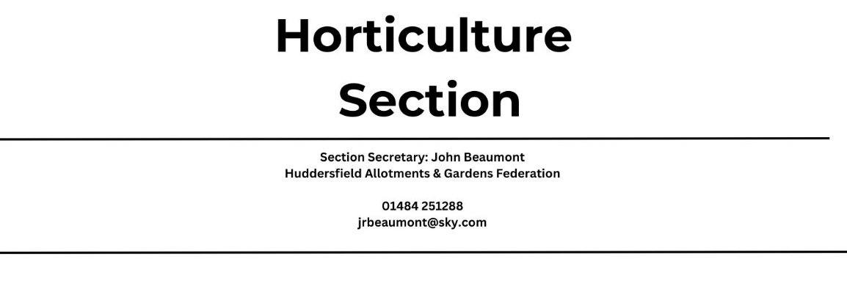

Huddersfield Allotments and Gardens Federation’s 2024 flower and vegetable show to be held within Emley Show on Saturday 3rd August 2024.

This is an open show, inviting everyone to exhibit.

Entries will be taken at the showground Friday 2nd August 4pm-9pm and on Saturday 3rd 7.30am-9.30am.
Please note that all vehicles must be removed from the showground before 9am on Saturday Morning.
Please have all Entry Forms completed before arrival to the desk. Entry forms will also be available on the day at the desk.
ALL CLASSES ARE FREE TO ENTER

A maximum of 2 exhibits per person, per class will be aloud.
Entry Cards will be provided for each exhibit: these should be placed face down under the exhibit.
All Plates, Vases and Sand will be provided by the federation.

TENT TO BE CLOSED 10AM PROMPT FOR JUDGING
The Decision of the judges are final, all matters in dispute will be settled by the show secretary.
Exhibits must not be removed from the show bench before 4.30pm.
Exhibits not removed by 5pm may be sold or given away.

Prize Money

Flower & Vegetable Classes
1st £5, 2nd £3, 3rd £1
Children’s Classes
1st, 2nd & 3rd Place will be awarded a rosette and a gift from the federation
Prizes are avalible for collection after the Trophy Presentation at 3pm.

Trophies
Where trophies are to be decided by points, they will be awared as follows
1st 5 Points, 2nd 3 Points, 3rd 1 Point.

John Armitage Trophy awared to The Best Exhibit in the Flower Section
NVS Medal & Certificate awarded to The Best Exhibit in the Vegetable Section
Eddie Dean Trophy awarded for Most Points in the Vegetable Section
Boots Trophy awarded for Most Points Awarded in the Flower Section
Frank Roebuck Trophy awarded for Best Collection of Three Vegetables; Class V1
Gerald Greenwood Trophy awarded for Best Gladioli; Class F3
Haigh Trophy awarded for Best Collection of Vegetables by a Garden or Allotment Group; Class V15
Michael Haigh Trophy awarded for Heaviest Potatoe; Class V12

Vegetable Classes
V1 : A Collection of 3 Different Kinds of Vegetables 2 of each (within an area 24 inches x 18 inches)
V2 : 2 Blanch Leeks Dressed with Roots Trimmed to Approx 3 inches
V3 : Dish of 3 Dressed Onions Under 250g
V4 : Dish of 3 Dressed Onions Over 250g
V5 : Heaviest Onion as Grown with Tops and Roots Intact, Washed and in Good Condition
V6 : Dish of 6 Shallots Dressed
V7 : Green Cabbage Dressed with 4 Guard Leaves and approx 3inch of Stem
V8 : 1 Red Cabbage Dressed with 4 Guard Leaves and approx 3inch of Stem
V9 : 1 Cauliflower Dressed with Approx 3Inch of Stem
V10 : Dish of 4 Potatoes White
V11 : Dish of 4 Potatoes with Colour
V12 : Heaviest Potato as Grown, Washed and in Good Condition
V13 : Dish of 4 Tomatoes with Calyx (Not Small Fruited)
V14 : Dish of 8 Small Fruited Tomatoes with Calyx
V15 : 6 Different Kinds of Vegetable from a Garden or Allotment Site any quantity of vegetable (within an area 24inch x 24 inch)
V16 : Dish of 6 Pod of Peas over 4.5 Inches with Stalk Intact
V17 : Dish of 6 Pod of Peas under 4.5 inches with Stalk Intact
V18 : Dish of 6 French Beans with Stalk Intact
V19 : Dish of 6 Runner Beans with Stalk Intact
V20 : Dish of 6 Broad Beans with Stalk Intact
V21 : Dish of 3 Beetroot with Roots Intact and Tops Trimmed to Approx 3inches
V22 : Dish of 3 Carrots with Roots Intact and Tops Trimmed to Approx 3inches
V23 : 1 Cucumber
V24 : 1 Marrow Max Length 15Inches
V25 : Dish of 3 Courgettes Round or Long. Max Length of Each Long Courgette 6inches
V26 : 1 Lettuce with Roots Intact
V27 : Dish of 6 Radish with Tops and Roots Intact
V28 : Collection of Mixed Herbs Displayed in a Jam Jar
V29 : Any Other Kind of Vegetable One Exibit
V30 : One Funny or Wonky Vegetable
V31 : Dish of Any Fruit

Flower Show
F1 : 1 Flower & 1 Vegetable
F2 : Vase of Sweet Peas 5 Stems
F3 : Gladioli 1 Spike
F4 : Vase of 3 Gladioli Spikes
F5 : Foliage Pot Plant Max 6 Inch Pot
F6 : 3 Pompom Dahlias
F7 : 3 Dahlias Any Variety
F8 : 3 Dahlias Same Variety
F9 : Flowering Pot Plant Max 6 Inch Pot
F10 : 1 Stem of Floribunda Roses
F11 : Vase of 3 Roses
F12 : Geranium Max 6 Inch Pot
F13 : Container of 1 Cactus or Succulent
F14 : Gents Buttonhole
F15 : 1 Basket of Flowers
F16 : Fuchsia Max 6 Inch Pot
F17 : 1 Vase of Mixed Flowers
Please Note all flowers to be staged in the federation vases.

Childrens Classes
Up to 13 Years

C1 : A Sunflower grown by yourself & displayed laid flat on the table. Stem to be up to a maximum length of 30cm, up to 7 years of age
C2 : A Drawing or Painting of a Flower or Vegetable on A4 paper or card, with name and age written on the back
C3 : A Face on a Plate made from Fruit and or Vegetables 8-13 years of age
C4 : A Drawing or Painting of a Flower or Vegetable on A4 paper or card with name and age written on the back.
C5 :An Animal made from Fruit and or Vegetable

