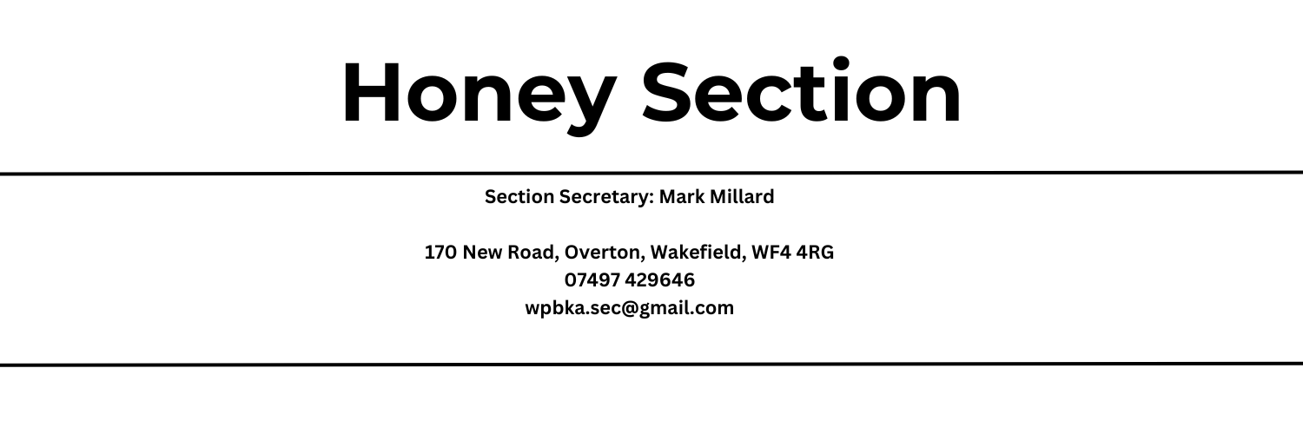

Please see attachments for rule, regulations and entry form.
Any additional questions please contact the secretary

Entry Fee = 50p per entry. Entries on the day will be extra 10p per item
Entries £4 + will qualify for exhibitors pass if received before show day
Cheques payable to ‘Emley Show Society’
For details of Emley Show rules and regulations please refer to our website

Open Classes
Prizes: 1st - £3.00, 2nd - £2.00, 3rd - £1.00
Judges Mr D Shannon : Wroot, Doncaster
Ms E Hargreaves : Preston

1201 Two 1lb (454g) jars light honey
1202 Two 1lb (454g) jars medium honey
1203 Two 1lb (454g) jars dark honey
1204 Two 1lb (454g) jars soft set or granulated honey (see Rule 11)
1205 Two 1lb (454g) jars heather/heather blend honey
1206 One 1lb (454g) “BLACKED OUT” JAR OF HONEY. Honey to be judged on taste and flavour only, but must be free of wax, foreign matter and defects. The sleeve will be provided by the show organisers
1207 One bottle of dry mead (see Rule 7)
1208 One bottle of sweet mead (see Rule 7)
1209 One cake of beeswax between 8oz (227g) and 16oz (454g) (see Rule 6)
1210 One comb of honey suitable for extraction, excluding heather honey (see Rule 5)
1211 Honey cake – Exhibitors own recipe. Sweetened only with honey. List of ingredients to be displayed on a card
1212 One pair of any type of beeswax candles. One to be lit by Judge.

Yorkshire Beekeepers Association Classes
Open to members of YBKA only
The judge’s decision on all class results is final
Prize cards will be awarded for 1st to 3rd placed exhibits in all classes, subject to merit
Trophies are offered by the Yorkshire Beekeepers’ Association
Trophies are perpetual and cannot be won outright.
Chief Steward
Mark Millard, Wakefield, West Yorkshire
Deputy Chief Steward
Tony Jefferson, Whitby, North Yorkshire
Prizes: - The appropriate Trophy

1214 Two 1lb (454g) jars light honey
1215 Two 1lb (454g) jars medium honey
1216 Two 1lb (454g) jars dark honey
1217 Two 1lb (454g) jars granulated honey (see Rule 11)
1218 Two 1lb (454g) jars soft set honey (see Rule 11)
1219 Two 1lb (454g) jars heather/heather blend honey
1220 Three 1lb (454g) jars of assorted honey (three distinct varieties)
1221 Two 1lb (454g) jars of honey exhibited by a Novice (see Rule 14)
1222 One comb of any honey suitable for extraction (see Rule 5)
1223 Two pieces of cut comb honey, flower or heather, presented in standard commercial containers. Min Weight 8oz (225g). Place 1 label in top R/H corner.
1224 One cake of beeswax between 12oz (340g) and 18oz (510g)
1225 Decorative beeswax models min of 3 max 6. Area 305mm x 305mm maximum
1226 One bottle dry mead (see Rule 7)
1227 One bottle sweet mead (see Rule 7)
1228 One bottle melomel mead (see Rule 7) - exhibitor to state on a label located opposite side to class label, fruit type and whether sweet or dry.
1229 One Honey cake to the following recipe: -
8oz (225g) self raising flour, 6oz (170g) honey,
4oz (113g) butter, 6oz (170g) sultanas, 2 eggs a pinch of salt.
Bake in 7-inch cake tin, moderate oven for approx. 90 mins.

Rules and Regulations of the Honey Show Section
- Exhibitors must label exhibits with the labels provided as follows:
Honey: 1” (2.5cms) between the bottom of the jar and the label
Mead: 1” (2.5cms) between the bottom of the bottle and the label
Wax cakes: Labels to be fixed to show case or polythene bag and bottom of wax cake
Honey cakes: to be presented on a plain paper plate. Contained in clear polythene bag.
Labels fixed on plate and top right corner of bag.
Comb: Labels to be fixed to top right-hand corner of showcase and on top bar of frame.
- No exhibitor’s name, card, trademark or label may appear on any exhibit.
- All honey must be the produce of the exhibitor’s own bees. Extracted honey must be exhibited in clear glass 1lb (454g) jars, of British Standard (Squat) design with standard gold lacquered screw caps. All jars must be matched pairs of the same type.
- ‘Light / Medium/ Dark’ relativity will be defined using NHS (BD) grading glasses.
- Combs should be exhibited in an appropriate case.
- Wax must be the produce of the exhibitor’s own bees and the wax rendered and prepared by the exhibitor or their assistant. Wax to be weighed by the judge.
- Mead must be exhibited in plain glass bottles of approx. 26fl.oz (76cl) capacity with rounded shoulders. Level of mead must be within ¾” (1.8cm) of the base of the stopper & white plastic-topped cork stoppers only to be used
- Exhibitors can have more than one entry in a class but no single entry may be shown in more than one class. An exhibitor will be entitled to only one award in any one class.
- Open classes are open to any resident of the United Kingdom.
- Exhibits must not be tasted or interfered with in any way during the show without authority of the Stewards.
- Definitions: Soft Set Honey is honey which has been softened, stirred and allowed to reset.
Granulated Honey is set honey that is not soft set or creamed
- Trophies will be awarded in classes 1214 – 1229. Both open and WPBKA classes will be eligible to be awarded the Blue Ribbon for best exhibit.
- Any Rule not covered by the Rules and Regulations of the Honey show Section will be in accordance with Rules of The Yorkshire Beekeepers’ Association Honey Show.
- Entry fee: 50p per entry. Entries on the form provided by 01 August 2023.
Class 1221 Novice – Free Entry. A Novice is anyone who has not previously won a first prize in any class in the Honey Section of the Emley Show.
Entries made on day of show; extra 10p per entry.
Entries to the value of £4 and over will qualify for an exhibitor’s pass. (If received BEFORE SHOW DAY)
- Staging of exhibits must be made by 09:30 on day of show.
ALL VEHICLES MUST BE REMOVED FROM THE SHOWGROUND BY 9.00AM

