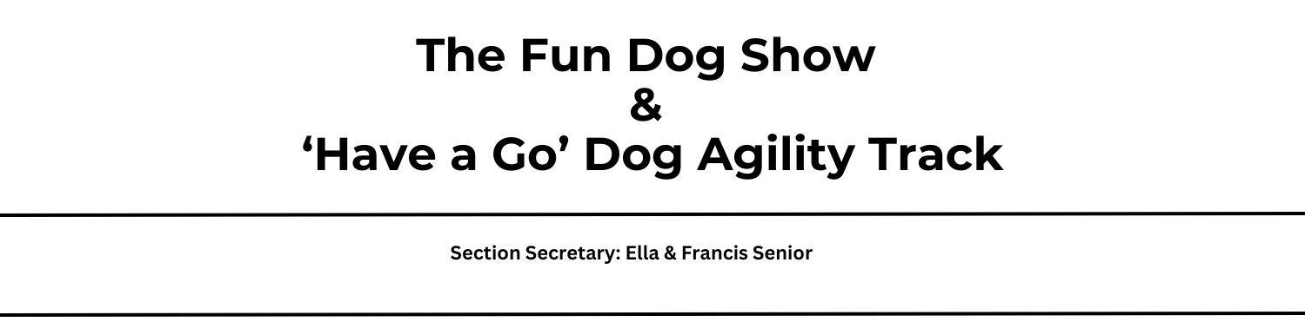

The Fun Dog Show is an ideal way for both the handlers and their dogs to share a fun time together. The classes are relaxed and include:
- Most obedient dog (split into two classes depending on the age of the handler – handlers 16 years and under will be entered into the Junior Obedience class)
- Prettiest Girl and Handsomest Boy
- Cutest Puppy (dogs under the age of 1 year)
- Best Veteran (‘veteran’ status will be determined by dog owner/handler)
- Scruffiest dog
- Waggiest Tail
- Best In Show (Selected from the class winners)
Entry Fee : £2 per dog, per class
Entries on the day from 9.30am
Dogs & Handler be at the Dog Tent 5 minutes before the class time
The dog agility track opens at 9.30 am and is available throughout the day.
This is a non competitive, fun activity for the handler and their dog to enjoy.
Class | Time
Junior Obedience | 10:30am
Waggiest Tail | 11:00am
Scruffiest Dog | 11:30am
Obedience | 12:00pm
Prettiest Girl | 13:30pm
Handsomest Boy | 14:00 pm
Best Veteran | 14:30pm
Cutest Puppy | 15:00pm
Best in Show | 15:30pm

