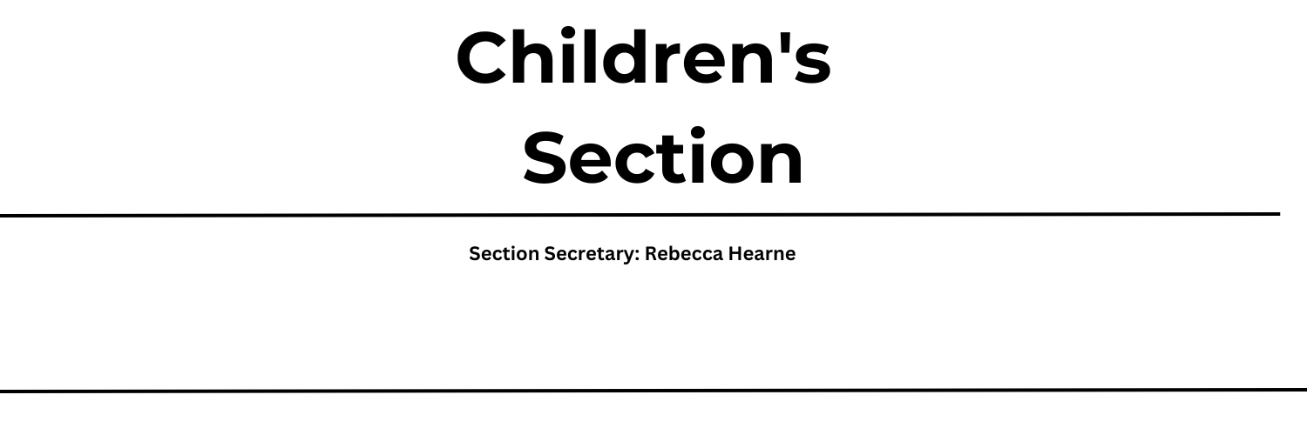

The theme has been selected to reflect on the wonder of flight and how humans have studied nature to find our own ways to fly.
This covers such a huge area, from insects and birds who have the natural ability to fly, through to humans who have studied nature and over the years have developed their own techniques to take to the air – some more successful than others!
We welcome entries covering flight from any and all perspectives. Children are invited to enter any of the classes outlined below and are encouraged to research flight in nature OR the history of flight to give them inspiration.
All Classes are Free to Enter
Please note that Emley Show is a ticketed event and to gain entry into the showground tickets must be purchased either through the website or on the gate
Prizes
1st– Paper Planes to Fold & Fly Book
2nd– Rosette
3rd – Rosette

 | Age 3-4 | Age 5-8 | Age 9-11 | Age 12-15
Recycled art | 950 | 951 | 952 | 953
Photography | X | 954 | 955 | 956
Lego model | X | 957 | 958 | 959
Baking – healthy sweet treats | 960 (decorating a sweet treat) | 961 | 962 | 963
Handwriting / Poetry | X | 964 | 965 | 966
Painting, Pencil, Crayons | 967 | 968 | 969 | 970
Handicraft | 971 | 972 | 973 | 974
‘Recycled art’ is a freestyle class – children may enter a model, collage, painting, sculpture, or handicraft. The only requirement is that the materials used should be predominantly recycled from household waste, such as old clothes, packaging, natural materials found in the wild etc.

