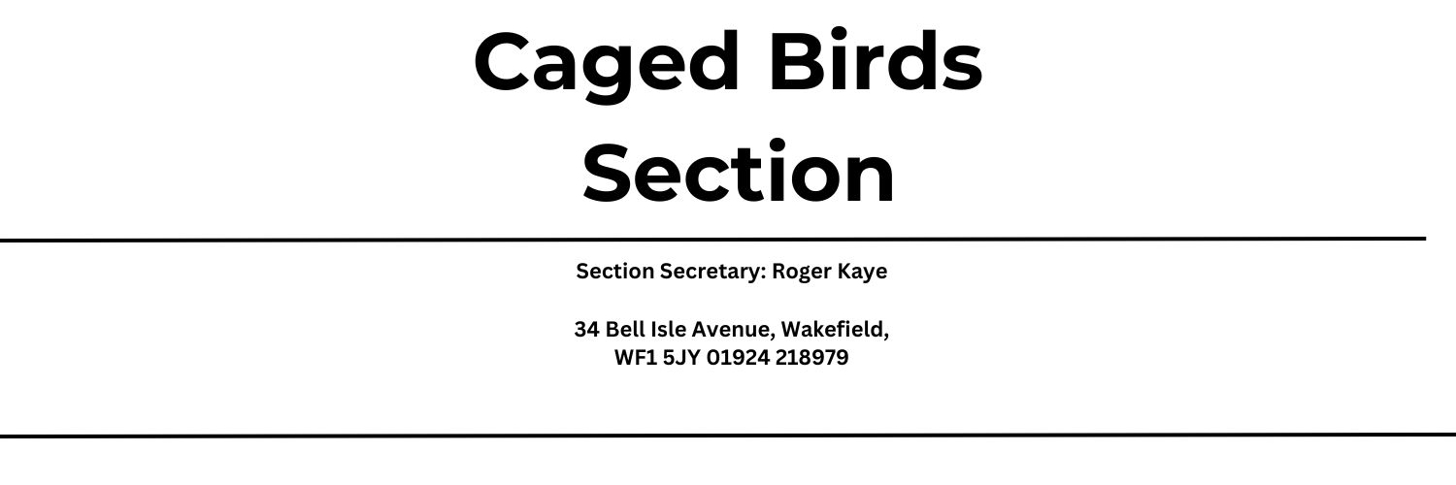

Wakefield Caged Birds Society presents their annual show on Saturday 3rd August 2024 at The Emley Show, Factory Farm, Emley Moor, Emley, HD8 9TE.
Please be aware that an entry ticket is required for this event. Online tickets can be purchased at www.emleyshow.co.uk for a discounted price or at the gate on showday.
Dogs are allowed at this show, but not in the tents or animal exhibit areas.

Entries Taken 8am – 11am on Show Day
All vehicles to be removed from the showground by 9am on Saturday morning

All Birds to be in clean cages with clean water
All Birds to comply with the 1981 Act
Judges to be confirmed

Entry Fees - 30p per Entry
Rosettes will be present to all section winners

Champion Class | Border Canary | Novice Class
1101 | Any variegated yellow cock | 1106
1102 | Any variegated buff cock | 1107
1103 | Any variegated yellow hen | 1108
1104 | Any variegated buff hen | 1109
1105 | Any white Ground | 1110
Champion Class | Gloster Canary | Novice Class
1111 | Buff consort cock/hen | 1115
1112 | Buff Corona cock/hen | 1116
1113 | AOC Consort cock/hen | 1117
1114 | AOC Corona cock/hen | 1118
Champion Class | New Colour Canary | Novice Class
1119 | Any variety cock | 1121
1120 | Any variety hen | 1122
Champion Class | Norwich Canary | Novice Class
1123 | Any colour cock | 1125
1124 | Any colour hen | 1126
Champion Class | Lizard Canary | Novice Class
1127 | Any colour cock | 1129
1128 | Any colour hen | 1130
Champion Class | Fife Canary | Novice Class
1131 | Any variegated yellow cock | 1136
1132 | Any variegated buff cock | 1137
1133 | Any variegated yellow hen | 1138
1134 | Any variegated buff hen | 1139
1135 | Any white ground | 1140
Champion Class | Budgerigars | Novice Class
1141 | Normal green cock/ hen | 1150
1142 | Normal grey- green cock/ hen | 1151
1143 | Normal blue cock/ hen | 1152
1144 | Normal grey cock/hen | 1153
1145 | All opaline green series cock/hen | 1154
1146 | All opaline blue series cock/hen | 1155
1147 | Any cinnamon cock/hen | 1156
1148 | Any red eyed cock/hen | 1157
1149 | Any other colour cock/hen | 1158
Champion Class | Yorkshire | Novice Class
1159 | Any variety cock | 1161
1160 | Any variety hen | 1162
Champion Class | British | Novice Class
1163 | Any variety cock | 1167
1164 | Any variety hen | 1168
1165 | Any mule cock/ hen | 1169
1166 | Any hybrid cock/ hen | 1170
Champion Class | Parrot- like | Novice Class
1171 | Any parrot like cock/hen
1172 | Common seed eaters/ Australian finches
1173 | Zebra finch any variety
Champion Class | Juvenile section | Novice Class
1174 | Any variety Canary cock/hen
1175 | Any variety Budgerigar cock/hen
1176 | Any variety British cock/hen
1177 | Any variety Foreign or zebra
1178 | Pet Bird Section

